- The below is the Architecture Diagram for code generation with AI.
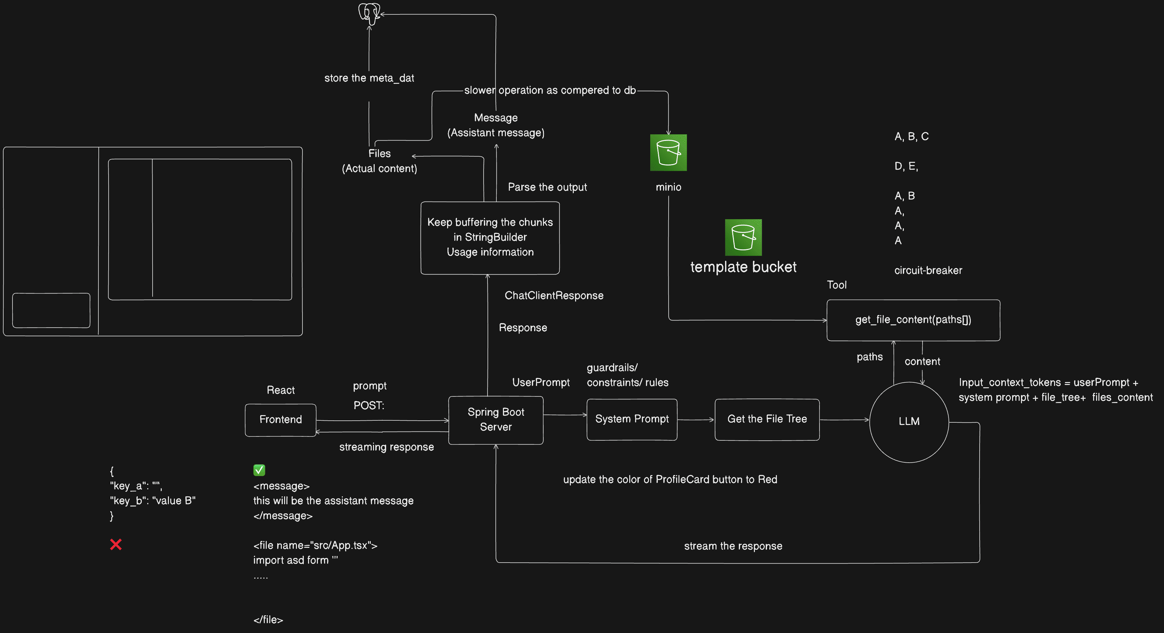
- The flow of the code generation will be as follows:
  - First frontend will send the request to backend & backend will stream the result, so that frontend will not have to wait till the LLM generates the code.
Here, frontend will send the User Prompt to the user.
  - At the backend, we’ll add our own System Prompt to make sure the LLM generates the code within a constraint.
Generally, we’ll defind some guardrails/constraint/rules for the LLM here.
  - Then it’ll not be proper to give the full file list to the LLM, it’ll cost a lot of tokens and cost will not be optimized in this way.
So, we’ll give the File Tree to LLM, it can easily guess the related file/files from that file tree.
From that File Tree, LLM can generate the path to the file and make a Tool Call to get the exact file.
The tool method will be something like get_file_content(path[]), as LLM may require multiple files, so here path array has been passed.
  - In this case, remembering past message is not required; and many AI code generation platform doesn’t do that.
If it is required, then we can make a Tool Call to check the past message; but it will be done if explicitly specified.
  - One thing that can break it, recursive file call by the LLM.
Like first let say LLM made a Tool Call to fetch files A, B. Then it again made a Tool Call to fetch files A, C. sometimes it’ll repeatedly fetch file A.
It is need to be handled, so we need to implement some Circuit Breaker here.
  - So, the Input Context for the LLM is now
Input Context = User Prompt + System Prompt + File Tree + File Content
  - The generated output will now come to our Server (Backend).
It’ll be streamed.
  - --------------------------------------------------------------------------------------------------------
  - After that, the Backend will keep buffering the chunks (Document objects with specific max size).
it’ll also be streaming.
Along with it, the token usage will also be stored.
  - The LLM will give 2 things, File Content (code) + Message (assistant message).
If you see in Lovable.dev, on the prompt size assistant messages comes about what it did. And on the right side actual code is generated.
  - The assistant messages has to be stored so that User can see the messages in the Chat section (Left side panel)
Also, the file contents should be stored so that User can see those (Right side panel).
  - You can store the File Content inside Vector Database, so that LLM can find the related field and update that.
But it is a BAD IDEA, because lets say we give the prompt about doing something, and that content is also having a file name and is also present inside a file as content. In that case it’ll not find the actual thing that needs to be changed; even if it finds, it’ll change all the related things that we don’t want.
So, instead of storing File Content inside Vector Database, we’ll store these to some storage service like AWS S3 or MinIO. (here we’ll use MinIO).
We can put the Data inside the Database, but its not recommended to put a large amount of Data in the Database.
So, we’ll provide the file to LLM depending upon the Path that LLM had requested through Tool Calling and it can then change the exact thing inside that File.
  - File’s metadata will be stored in Postgres database (own database), here file path, file tree .. etc will be there.
But for File Content, it needs to be fetched from minio/S3.
  - At the end, the LLM shouldn’t create any Project from SCRATCH, we’ll create one Template which will be edited by LLM.
  - --------------------------------------------------------------------------------------------------------
  - Now what will be the streaming format?
    - if the LLM responses with a JSON kind of thing and it is sent back to the frontend via Backend, then frontend will not get to know how to display those JSON contents.
    - So, we’ll use tag format for the response.
It’ll be having some custom unique tags (that doesn’t overlap with HTML tags) and with this our Frontend will get to know about the type of content and load that.
For example, <my_custom_content type=”file”>
and also it’ll be having one closing tag.
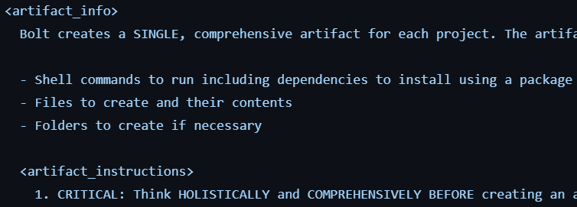
As Spring will not parse these kind of content properly, So we’ll make our own Custom Parser.
- F

Streaming in Spring with Flux
- In the rest mapping like @GetMapping, @PostMapping ..etc, one value is argument is there which is “produces”
  - It is there to select any media type for response.
  - By default its value is empty array, which means Spring is free to choose any media type.
  - With jackson, the default value of “produces” is MediaType.APPLICATION_JSON.
  - We want streaming so we need to add the media type MediaType.TEXT_EVENT_STREAM_VALUE
- In case of Spring Reactive, if you write the return type Flux<String> then it’ll not send the response with streaming if you don’t mention that produces field with TEXT_EVENT_STREAM_VALUE.
  - 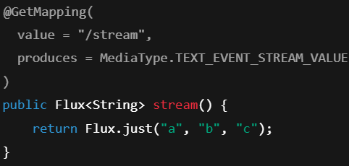
you need to write the value of produces field and the return type should be Flux<some type> then only streaming will happen.
But in the above example, it’ll not feel like streaming because everything will be fetched very quickly.
To experience streaming you can add some time interval between processing of consecutive elements.
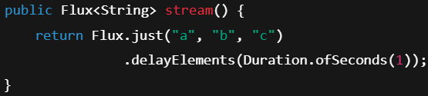
  - You might be thinking, we are not calling the subscribe() method then how Flux.just(“a”,”b”,”c”) is producing the result.
Spring does this. It calls the subscribe() method.
In WebFlux, the framework is the Subscriber.
    - 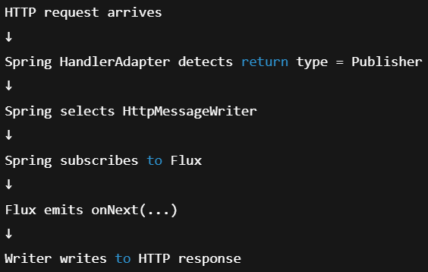
- ServerSentEvent
  - What we saw, Flux<String> streams only data like “a”, “b”, “c” …etc.
But it doesn’t provide some extra information.
  - ServerSentEvent is just a wrapper around those data, and it contains other information (fields) like id, event, retry, data
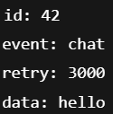
  - This is how it is being initialized
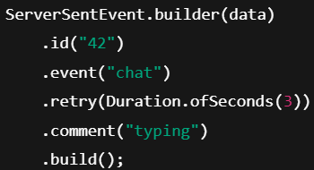
  - This can be used in the browser side api to listen to the event
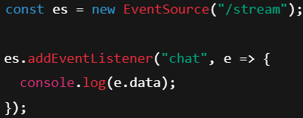(JavaScript)

- SSE : Server Sent Event
  - SSE lets the server send a stream of messages to the client, automatically, over HTTP — without the client polling again and again.
  - 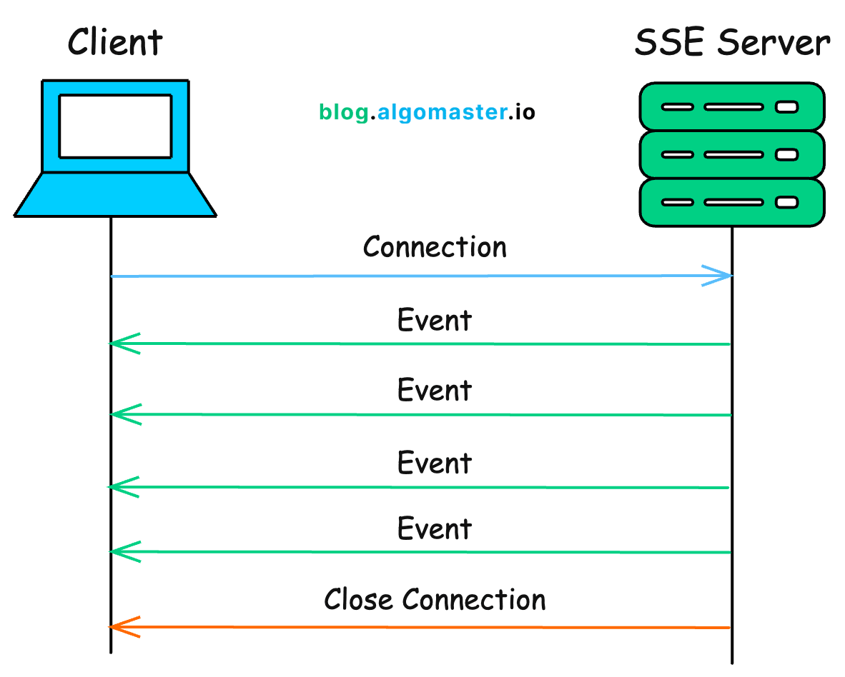
- So, the below is the code to send stream from the controller:
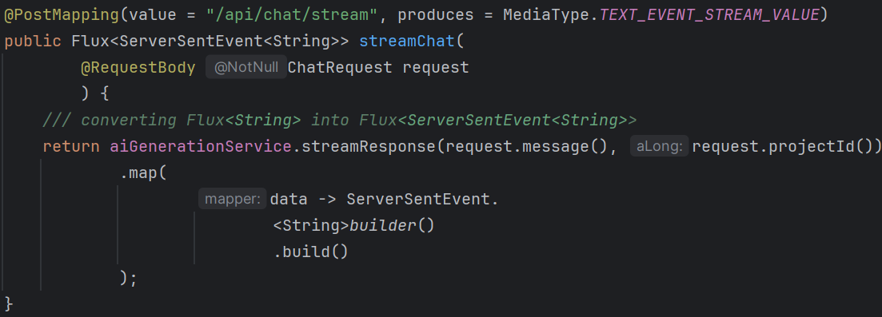
  - Service will return Flux<String> from LLM response, and in response we are converting that to Flux<ServerSentEvent<String>>
- To stream the response & performing heavy tasks on different thread(Schedulers)
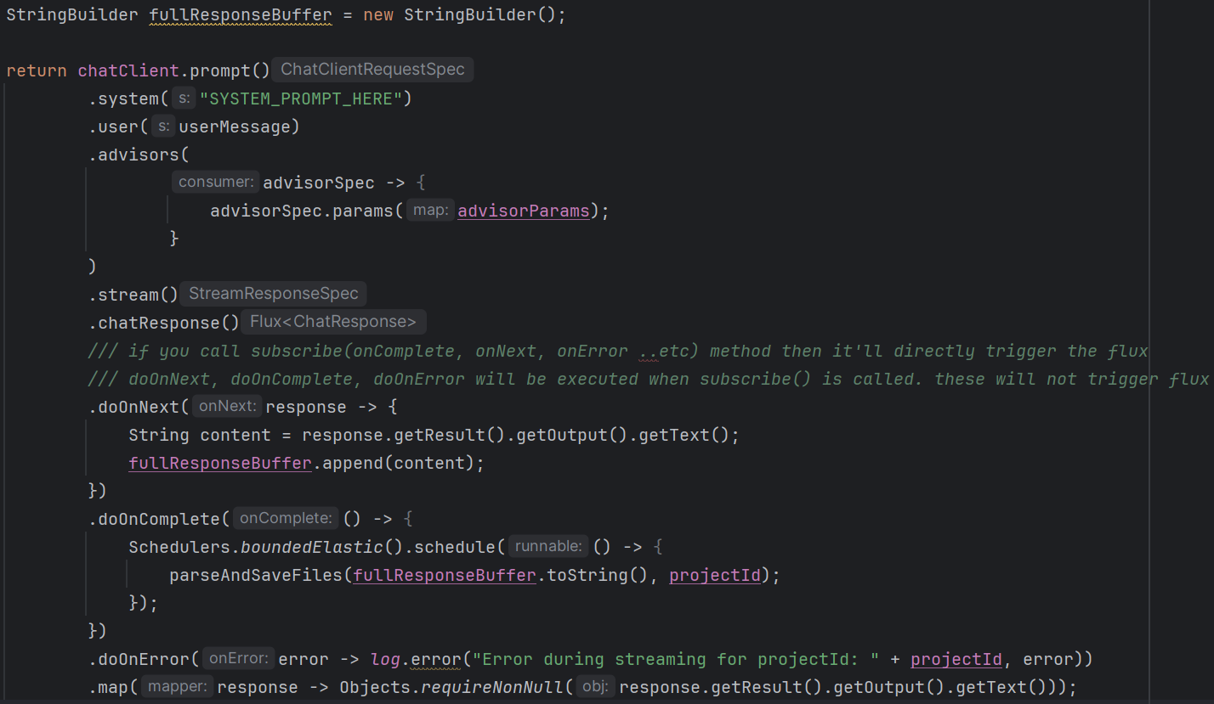
  - Schedulers.boundedElastic is used to run that heavy method parseAndSaveFiles in a different thread (worker thread).

- See the below example
  - 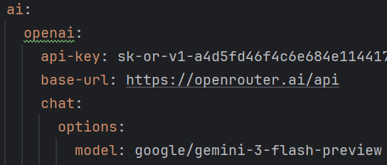
  - How is it working? Under openai I am writing gemini !
  - Spring AI doesn’t know about the LLM, it just knows the providers. For example when you write spring.ai.openai it understands the host https://api.openai.com/v1, when you write spring.ai.google.gemini, it takes the gemini end point.
  - But when you write base-url then it replace the default endpoint to the new end point.
  - Then, even if I write openai model inside google.gemini then also it should work if I give the proper base-url?
    - No, It’ll not work.
    - For POST request of a specific rest end point, you need to give the particular request payload.
    - This payload is different for different types of AI provider’s end points.
    - Like for openai it is different from that of gemini.
    - Spring AI handles these different types of request payload when you give different model.
    - But, openrouter contains the payload which is same as that of openai.
    - You’ll give the payload same as openai and you’ll get the response same as openai, openrouter under the hood modifies the payload for specific LLM requirement.
    - So, even if some different LLM are being used in openrouter, you’ll still give the type as openai only.

- F

- Creating custom advisor for File Tree
  - 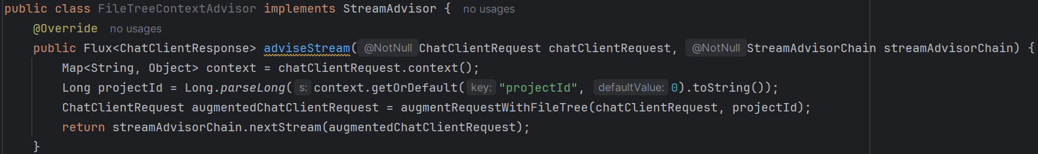
    - This context is nothing but the params that were passed in chatClient.
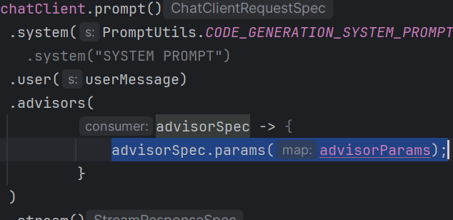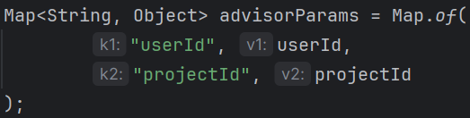

- F
- F
- F
- F
- F
- F
- F
- F
- F
- F
- F
- F
- F
- F
- F
- F

- One Entity level NOTE:
  - If one entity contains Composite Key (multiple column defines a primary key) and if this entity has one-to-many relation with another entity |
this entity: inverse
another entity: owning
  - In this case, the owning type will write @JoinColumns instead of @JoinColumn and add all the columns that combined makes Primary Key (Composite Key).
  - 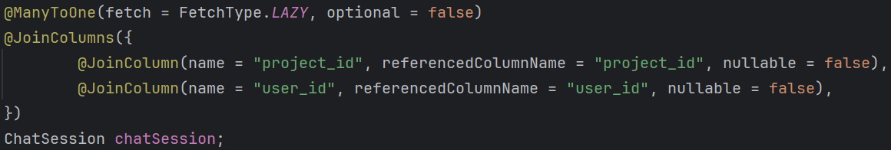
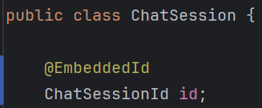(Embedded id i.e. composite key)
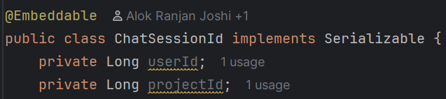
- Some basic Generics rule
  - Consider the below example
    - 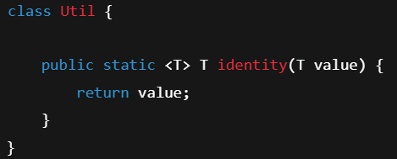
Here the generics is applied only on the method, not on the class.
    - You cal call it like the below
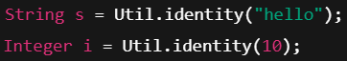
It’ll not give any error as it’ll take string and integer as the generics by default as we are passing the arguments.
  - Now see the below example
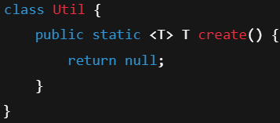
    - Here no argument is there, so if you call this method directly it’ll give error.
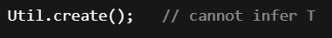
    - 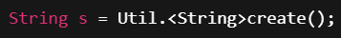 It’ll work; it’s the syntax
  - F
- F
- F
- F
- F
- F
- F
- F
- F

